实验编号：8 **四川师大Android高级开发实验报告 2020**年 **5**月 **15**日

**计算机科学学院** 级 3 班 实验名称： 音频播放和服务

姓名： 吴文娇 学号： 2017110543 指导老师： 樊相奎 实验成绩:_____

**实验 八 音频播放和服务**

1. 实验目的及要求

目的：

(1) 掌握 Andriod 中播放声频

要求：

(1) 认真填写实验报告，要求附加部分运行界面和主要代码;

(2) 对设计好的程序，检查输出是否符合预期，如有错请分析错误原因并解决;

1. 实验内容

(1) 查询所有的音频文件，获得文件列表;

(2) 实现界面控制的播放程序:播放、暂停、下一首;

(3) 采用服务实现音频播放;

(4) 在通知栏中实现音频播放程序:播放、暂停、下一首、退出服务;

1. 实验主要流程、基本操作或核心代码、算法片段（该部分如不够填写，请另加附页）

***1.acitivity_main.xml***

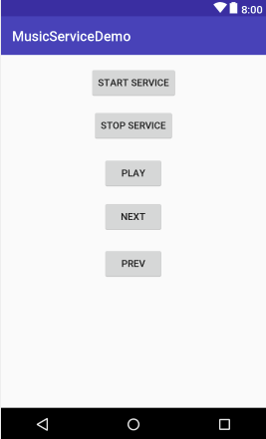

*<?***xml version="1.0" encoding="utf-8"***?>*<**android.support.constraint.ConstraintLayout xmlns:android="http://schemas.android.com/apk/res/android"  
 xmlns:app="http://schemas.android.com/apk/res-auto"  
 xmlns:tools="http://schemas.android.com/tools"  
 android:layout_width="match_parent"  
 android:layout_height="match_parent"  
 tools:context="cn.edu.sicnu.musicservicedemo.MainActivity"**>  
  
 <**Button  
 android:id="@+id/button"  
 android:layout_width="wrap_content"  
 android:layout_height="wrap_content"  
 android:layout_marginTop="16dp"  
 android:onClick="startService"  
 android:text="start service"  
 app:layout_constraintEnd_toEndOf="parent"  
 app:layout_constraintStart_toStartOf="parent"  
 app:layout_constraintTop_toTopOf="parent"** />  
  
 <**Button  
 android:id="@+id/button2"  
 android:layout_width="wrap_content"  
 android:layout_height="wrap_content"  
 android:layout_marginStart="4dp"  
 android:layout_marginTop="14dp"  
 android:onClick="stopService"  
 android:text="stop service"  
 app:layout_constraintStart_toStartOf="@+id/button"  
 app:layout_constraintTop_toBottomOf="@+id/button"** />  
  
 <**Button  
 android:id="@+id/button3"  
 android:layout_width="wrap_content"  
 android:layout_height="wrap_content"  
 android:layout_marginStart="15dp"  
 android:layout_marginTop="21dp"  
 android:onClick="playMusic"  
 android:text="play"  
 app:layout_constraintStart_toStartOf="@+id/button2"  
 app:layout_constraintTop_toBottomOf="@+id/button2"** />  
  
 <**Button  
 android:id="@+id/button4"  
 android:layout_width="wrap_content"  
 android:layout_height="wrap_content"  
 android:layout_marginTop="15dp"  
 android:onClick="nextMusic"  
 android:text="next"  
 app:layout_constraintStart_toStartOf="@+id/button3"  
 app:layout_constraintTop_toBottomOf="@+id/button3"** />  
  
 <**Button  
 android:id="@+id/button5"  
 android:layout_width="wrap_content"  
 android:layout_height="wrap_content"  
 android:layout_marginTop="20dp"  
 android:onClick="prevMusic"  
 android:text="prev"  
 app:layout_constraintStart_toStartOf="@+id/button4"  
 app:layout_constraintTop_toBottomOf="@+id/button4"** />  
</**android.support.constraint.ConstraintLayout**>

***2.MainActivity.java***

**package** cn.edu.sicnu.musicservicedemo;  
  
**import** android.Manifest;  
**import** android.content.ContentResolver;  
**import** android.content.Intent;  
**import** android.content.pm.PackageManager;  
**import** android.database.Cursor;  
**import** android.media.MediaPlayer;  
**import** android.provider.MediaStore;  
**import** android.support.annotation.NonNull;  
**import** android.support.v4.app.ActivityCompat;  
**import** android.support.v7.app.AppCompatActivity;  
**import** android.os.Bundle;  
**import** android.util.Log;  
**import** android.view.View;  
  
**import** java.io.IOException;  
**import** java.util.ArrayList;  
  
**public class** MainActivity **extends** AppCompatActivity {  
  
 **private static final** String ***TAG*** = **"MainActivity"**;  
  
  
 @Override  
 **protected void** onCreate(Bundle savedInstanceState) {  
 **super**.onCreate(savedInstanceState);  
 setContentView(R.layout.***activity_main***);  
  
 **if** (ActivityCompat.*checkSelfPermission*(**this**, Manifest.permission.***READ_EXTERNAL_STORAGE***) != PackageManager.***PERMISSION_GRANTED***){  
 ActivityCompat.*requestPermissions*(**this**,**new** String[]{Manifest.permission.***READ_EXTERNAL_STORAGE***},1);  
 }  
  
 }  
  
 **public void** startService(View view){  
 Intent intent = **new** Intent(**this**,MusicService.**class**);  
 startService(intent);  
 }  
 **public void** stopService(View view){  
 Intent intent = **new** Intent(**this**,MusicService.**class**);  
 stopService(intent);  
 }  
  
 **public void** playMusic(View view){  
 Intent intent = **new** Intent(**this**,MusicService.**class**);  
 intent.putExtra(**"operate"**,1);  
 startService(intent);  
  
 }  
 **public void** nextMusic(View view){  
 Intent intent = **new** Intent(**this**,MusicService.**class**);  
 intent.putExtra(**"operate"**,2);  
 startService(intent);  
 }  
 **public void** prevMusic(View view){  
 Intent intent = **new** Intent(**this**,MusicService.**class**);  
 intent.putExtra(**"operate"**,3);  
 startService(intent);  
 }  
  
  
}

***3.musiclayout.xml***

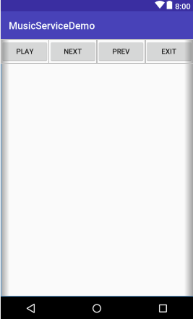

*<?***xml version="1.0" encoding="utf-8"***?>*<**LinearLayout xmlns:android="http://schemas.android.com/apk/res/android"  
 android:layout_width="match_parent"  
 android:layout_height="match_parent"**>  
  
 <**Button  
 android:id="@+id/button_play"  
 android:layout_width="wrap_content"  
 android:layout_height="wrap_content"  
 android:layout_weight="1"  
 android:text="play"** />  
  
 <**Button  
 android:id="@+id/button_next"  
 android:layout_width="wrap_content"  
 android:layout_height="wrap_content"  
 android:layout_weight="1"  
 android:text="next"** />  
  
 <**Button  
 android:id="@+id/button_prev"  
 android:layout_width="wrap_content"  
 android:layout_height="wrap_content"  
 android:layout_weight="1"  
 android:text="prev"** />  
  
 <**Button  
 android:id="@+id/button_exit"  
 android:layout_width="wrap_content"  
 android:layout_height="wrap_content"  
 android:layout_weight="1"  
 android:text="exit"** />  
</**LinearLayout**>

***4,Musicservice.java***

**package** cn.edu.sicnu.musicservicedemo;  
  
**import** android.app.Notification;  
**import** android.app.PendingIntent;  
**import** android.app.Service;  
**import** android.content.ContentResolver;  
**import** android.content.Intent;  
**import** android.database.Cursor;  
**import** android.media.MediaPlayer;  
**import** android.os.IBinder;  
**import** android.provider.MediaStore;  
**import** android.util.Log;  
**import** android.view.View;  
**import** android.widget.RemoteViews;  
  
**import** java.io.IOException;  
**import** java.util.ArrayList;  
  
**public class** MusicService **extends** Service {  
  
 **private static final** String ***TAG*** = **"MusicService"**;  
  
 ArrayList<String> **musicList** = **new** ArrayList<>();  
 ArrayList<String> **musicNameList** = **new** ArrayList<>();  
 Notification.Builder **builder**;  
 RemoteViews **remoteViews**;  
 MediaPlayer **mediaPlayer**;  
 **int current** = 0;  
  
 **public** MusicService() {  
 }  
  
 @Override  
 **public** IBinder onBind(Intent intent) {  
 *//* ***TODO: Return the communication channel to the service.* throw new** UnsupportedOperationException(**"Not yet implemented"**);  
 }  
  
 @Override  
 **public void** onCreate() {  
 **super**.onCreate();  
 getMusicList();  
 initNotification();  
  
 **mediaPlayer** = **new** MediaPlayer();  
 playNew();  
  
  
 }  
  
 **public void** initNotification(){  
 **builder** = **new** Notification.Builder(**this**);  
 **builder**.setSmallIcon(R.mipmap.***ic_launcher***);  
  
 **remoteViews** = **new** RemoteViews(getPackageName(),R.layout.***musiclayout***);  
 **builder**.setContent(**remoteViews**);  
  
 Intent intent = **new** Intent(**this**,MainActivity.**class**);  
 PendingIntent pendingIntent = PendingIntent.*getActivity*(**this**,0,intent,PendingIntent.***FLAG_UPDATE_CURRENT***);  
 **builder**.setContentIntent(pendingIntent);  
  
 Intent intentPlay = **new** Intent(**this**,MusicService.**class**);  
 intentPlay.putExtra(**"operate"**,1);  
 PendingIntent pendingIntentPlay = PendingIntent.*getService*(**this**,1,intentPlay,PendingIntent.***FLAG_UPDATE_CURRENT***);  
 **remoteViews**.setOnClickPendingIntent(R.id.***button_play***,pendingIntentPlay);  
  
 Intent intentNext = **new** Intent(**this**,MusicService.**class**);  
 intentNext.putExtra(**"operate"**,2);  
 PendingIntent pendingIntentNext = PendingIntent.*getService*(**this**,2,intentNext,PendingIntent.***FLAG_UPDATE_CURRENT***);  
 **remoteViews**.setOnClickPendingIntent(R.id.***button_next***,pendingIntentNext);  
  
 Intent intentPrev = **new** Intent(**this**,MusicService.**class**);  
 intentPrev.putExtra(**"operate"**,3);  
 PendingIntent pendingIntentPrev = PendingIntent.*getService*(**this**,3,intentPrev,PendingIntent.***FLAG_UPDATE_CURRENT***);  
 **remoteViews**.setOnClickPendingIntent(R.id.***button_prev***,pendingIntentPrev);  
  
 Intent intentExit = **new** Intent(**this**,MusicService.**class**);  
 intentExit.putExtra(**"operate"**,4);  
 PendingIntent pendingIntentExit = PendingIntent.*getService*(**this**,4,intentExit,PendingIntent.***FLAG_UPDATE_CURRENT***);  
 **remoteViews**.setOnClickPendingIntent(R.id.***button_exit***,pendingIntentExit);  
  
 startForeground(1,**builder**.build());  
  
 }  
  
 **public void** getMusicList(){  
 ContentResolver contentResolver = getContentResolver();  
 Cursor cursor = contentResolver.query(MediaStore.Audio.Media.***EXTERNAL_CONTENT_URI***,**null**,**null**,**null**,**null**);  
 **while** (cursor.moveToNext()){  
 String musicPath = cursor.getString(cursor.getColumnIndex(MediaStore.Audio.Media.***DATA***));  
 **musicList**.add(musicPath);  
 String musicName = cursor.getString(cursor.getColumnIndex(MediaStore.Audio.Media.***TITLE***));  
 **musicNameList**.add(musicName);  
 }  
 cursor.close();  
  
 Log.*d*(***TAG***, **"getMusicList: "**+**musicList**);  
 Log.*d*(***TAG***, **"getMusicNameList: "**+**musicNameList**);  
 }  
 @Override  
 **public int** onStartCommand(Intent intent, **int** flags, **int** startId) {  
 **int** operate = intent.getIntExtra(**"operate"**,0);  
 Log.*d*(***TAG***, **"onStartCommand: "**+operate);  
 **switch** (operate){  
 **case** 1:  
 playMusic();  
 **break**;  
 **case** 2:  
 nextMusic();  
 **break**;  
 **case** 3:  
 prevMusic();  
 **break**;  
 **case** 4:  
 stopSelf();  
 **break**;  
 }  
  
 **return super**.onStartCommand(intent, flags, startId);  
 }  
  
 @Override  
 **public void** onDestroy() {  
 **super**.onDestroy();  
 **mediaPlayer**.release();  
 }  
 **public void** playMusic(){  
 **if**(**mediaPlayer**.isPlaying()) {  
 **mediaPlayer**.pause();  
 **remoteViews**.setTextViewText(R.id.***button_play***,**"play"**);  
 startForeground(1, **builder**.build());  
 }**else**{  
 **mediaPlayer**.start();  
 **remoteViews**.setTextViewText(R.id.***button_play***,**"pause"**);  
 startForeground(1, **builder**.build()); }  
 }  
 **public void** nextMusic(){  
 **current**++;  
 **if**(**current**>=**musicList**.size()) **current** = 0;  
 playNew();  
 }  
 **public void** prevMusic(){  
 **current**--;  
 **if**(**current**<0) **current** = **musicList**.size() - 1;  
 playNew();  
 }  
  
 **public void** playNew(){  
 **try** {  
 **mediaPlayer**.reset();  
 **mediaPlayer**.setDataSource(**musicList**.get(**current**));  
 **mediaPlayer**.prepare();  
 **mediaPlayer**.start();  
 **remoteViews**.setTextViewText(R.id.***button_play***,**"pause"**);  
 startForeground(1, **builder**.build());  
 } **catch** (IOException e) {  
 e.printStackTrace();  
 }  
 }  
}

1. 实验结果的分析与评价（该部分如不够填写，请另加附页）

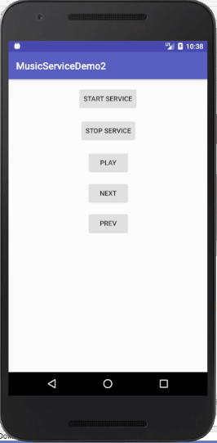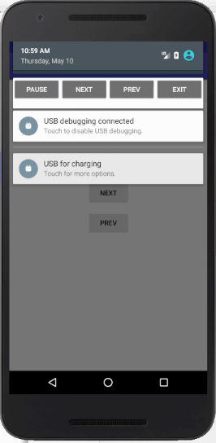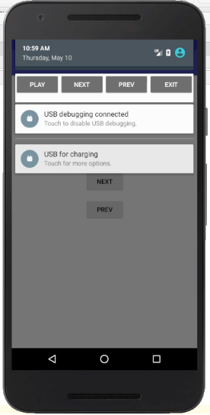

注：实验成绩等级分为（90－100分）优，（80－89分）良，(70-79分)中，（60－69分）及格，（59分）不及格。